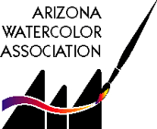

CALL FOR ENTRIES
AWA Spring 2017
MEMBERSHIP EXHIBITION

March 7th – April 25th
ASU Gammage
1200 S Forest Avenue, Tempe

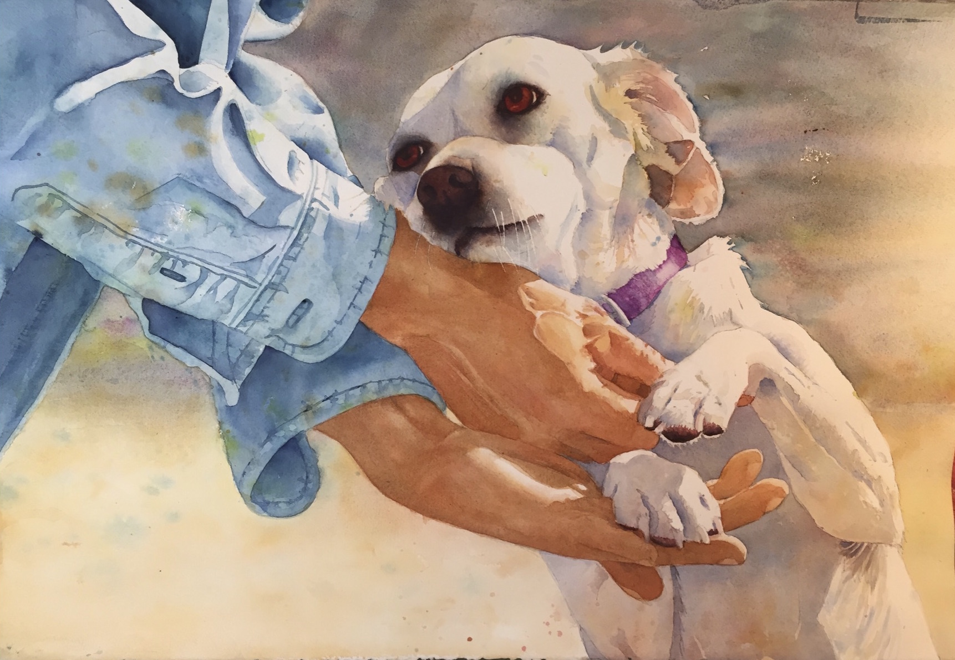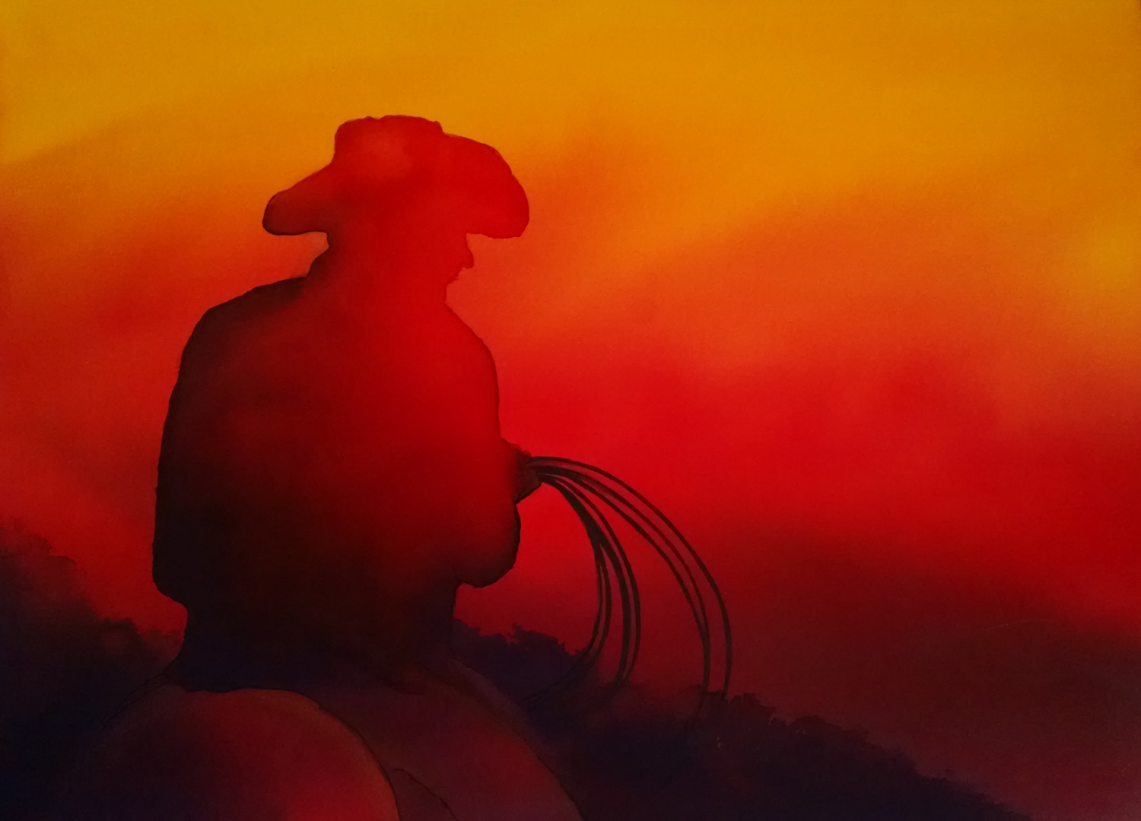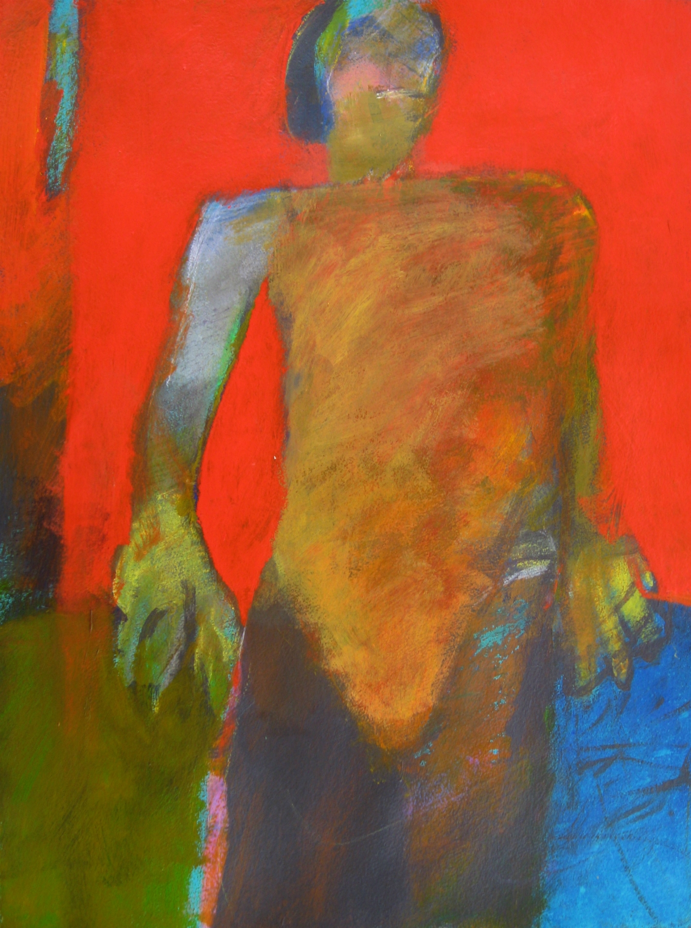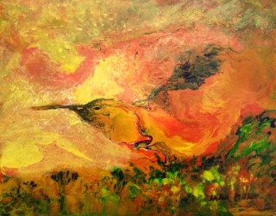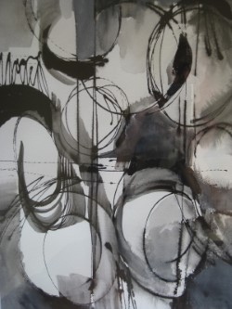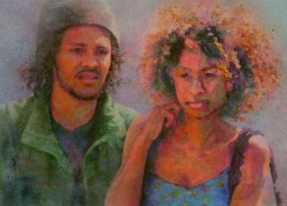

Spring 2017 Show Calendar

January 31: Deadline for Digital Entries
February 14th: Artists Notified
March 1st: Shipped Paintings are due
March 7th: (Saturday)10 to noon, Hang Show
March 7th: Show Opens
April 12 – 15th: Juror gives demo at AWA Mtg at AAG Bldg
April 13th: Artist Reception & Awards 6:45 pm at AAG Bldg
April 25th: Pick-up Paintings 10 till Noon
Awards
Best of Show, Awards of Excellence, Awards of Merit, Juror's Choice Award, Merchant Awards

Juror, Birgit O’Connor: An Internationally recognized artist, instructor and video producer, Birgit comes to AWA in April to offer her watercolor expertise to AWA members through her acclaimed workshops. She will use her many-faceted experiences to select the award winners of our 2017 Spring Exhibition.

Eligibility
The Spring 2017 Membership show is open to ALL MEMBERS with current dues paid.
Approximately 50 paintings will be selected. We are thrilled to hang our exhibition at the famed ASU Gammage Theater, where literally thousands of show patrons will be exposed to our work. Our exhibition will hang during two Broadway shows: “Finding Neverland” and “An American in Paris.”

Materials for this show (Read full description on website)
For this show only, framed paintings must be no wider than 26”.
AWA is a progressive supporter of water-based arts and invites your suggestions for advancing the art. This is a competition, so emphasis is placed on the work rather than on the framing. (Check framing requirements on website.) Various water-media including transparent watercolor, acrylic, and gouache are acceptable on all forms of white and off-white paper, synthetic paper (such as YUPO), or white paper surface on board. Clay surfaces are not acceptable, but gesso texture may be applied to the paper prior to painting. Textured boards, such as canvas surfaces, are not acceptable. White paper colored by the artist may be used for collage. Minimal image size is 10”x10”, maximum image must allow you to comply with no greater than 26” width rule as required by Gammage. No glass is allowed for this show; plexi only. Check azwatercolor.com under “Exhibitions” for complete updates of the rules. Work must be completed within three years of exhibition start date.

AZ Watercolor Association
Exhibition Guidelines

Digital Image Entry Information Submittal of a digital image grants AWA permission to use the image for limited publicity related to the show. Entries may be submitted on a CD or by e-mail to: Carol Baker, 18862 N 90th Way, Scottsdale, AZ 85255 or carolbakerart@cox.net before midnight, January 31st.
Submitted images are to be formatted as jpegs at 300 dpi and 1800 pixels as the longest side. Crop the image so that only the painting shows. Unless you have special lights, take the picture in natural daylight for accurate colors. A digital camera with megapixels of 10 or higher is best. Some computer e-mail programs, such as MacIntosh, automatically re-size photos to 72 dpi if you attach them to e-mail as a “picture”. This can be avoided by attaching images as “files.” If the image is manipulated to not faithfully show the painting, the painting will be disqualified.

Naming your image(s)
Each image must be named using the first four letters of your last name + first four letters of
your first name, hyphen(-), then the title of the painting. You may abbreviate the title. Example: a painting by Winslow Homer called “Sailboat” would be Homewins-Sailboat.jpg.

Images will be returned if they do not conform to the above format for re-sizing and naming. Please refer to our website for additional instruction information (azwatercolor.com) and/or find a friend who can help you.

Entry Fees
One entry: $30
Two entries: $35 total
Three entries: $40 total
A check made out to AWA and entry form must be mailed to: Jane Underhill, 7907
N 16th Dr, Phoenix, AZ 85021, no later than January 31st.

Accepted works
Notification will be sent to all entrants on February 14th with additional instructions for accepted work.

Labeling your paintings
The back upper right hand corner of your painting(s) should specify your name, image title, price/NFS and phone number.

Sales
AWA will arrange for buyers to contact artists for sales. Submittal for the show indicates permission to exhibit the work on the AWA website. Work is assumed for sale unless labeled “NFS.” In any case, list a value for insurance. No changes may be made after January 31st. Gammage requires a 10% commission on all sales.

Refer to resizing, matting and framing guidelines online: azwatercolor.com. Contact either Carol Baker (480-998-3166) or Jane Underhill (602-795-3545) with questions and/or for help.

Artist Checklist

For this show only, framed paintings must be no wider than 26”.
__ Photo work with the highest resolution possible.

___ Resize image(s) to 300 dpi and 1800 pixels on longest side.

___ Title images as example (above): Homewins-Sailboat.jpg.

___ Email jpeg(s) or mail a CD of digital images to: Carol Baker no later than January 31st: carolbakerart@cox.net or 18862 N 90th Way, Scottsdale, AZ 85255.

___ Mail your entry form and fee check before the deadline of January 31st to: Jane Underhill, 7907 N 16th Dr, Phoenix, AZ 85021.

___ Save a copy of the prospectus and your completed entry form to refer to.

___ Label the back of your painting(s) as directed above.

Happy painting and good luck!

Spring 2017 Exhibition Entry Form

Artist: ____________________________________________
Address: __________________________________________
City/State/Zip: _____________________________________
Phone: ( ) _______ - _______________
E-mail address: _____________________________________

Entry 1
Digital file Name:
Title: _____________________________________________
Price (or insurance value if NFS) $______________________
Frame Size: H__________ x W _________

Entry 2
Digital file Name:
Title: _____________________________________________
Price (or insurance value if NFS) $______________________
Frame Size: H__________ x W_________

Entry 3
Digital file Name:
Title: _____________________________________________
Price (or insurance value if NFS) $______________________
Frame Size: H__________ x W_________

Agreement: Submission of digital image(s), if accepted, shall be an agreement on the part of the artist to comply with the following conditions: Entry images of accepted paintings go into the AWA collection. Accepted entries will be featured on the AWA website and, if for sale, prices will be indicated. Artists who renege or withdraw work prior to the close of the show will not be eligible to enter an AWA show for a period of one year. Work not removed at the end of the show will result in a fine of $10 per day unless prior arrangements have been made. AWA will attempt to contact you. After one week, the artist is ineligible to enter the following AWA show. After one month, the artist forfeits the painting to the AWA. I hereby agree to release show personnel and venue staff from all claims or loss of paintings or digital images.

Artist Signature Date

Please include the artist's name, painting title, price and phone number
on the back of each painting.

