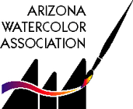

CALL FOR ENTRIES
AWA SPRING 2016
MEMBERSHIP EXHIBITION

April 6 to May 6, 2016
Burton Barr Central Library
2nd Floor
1221 N Central Avenue, Phoenix, AZ
602-262-4636

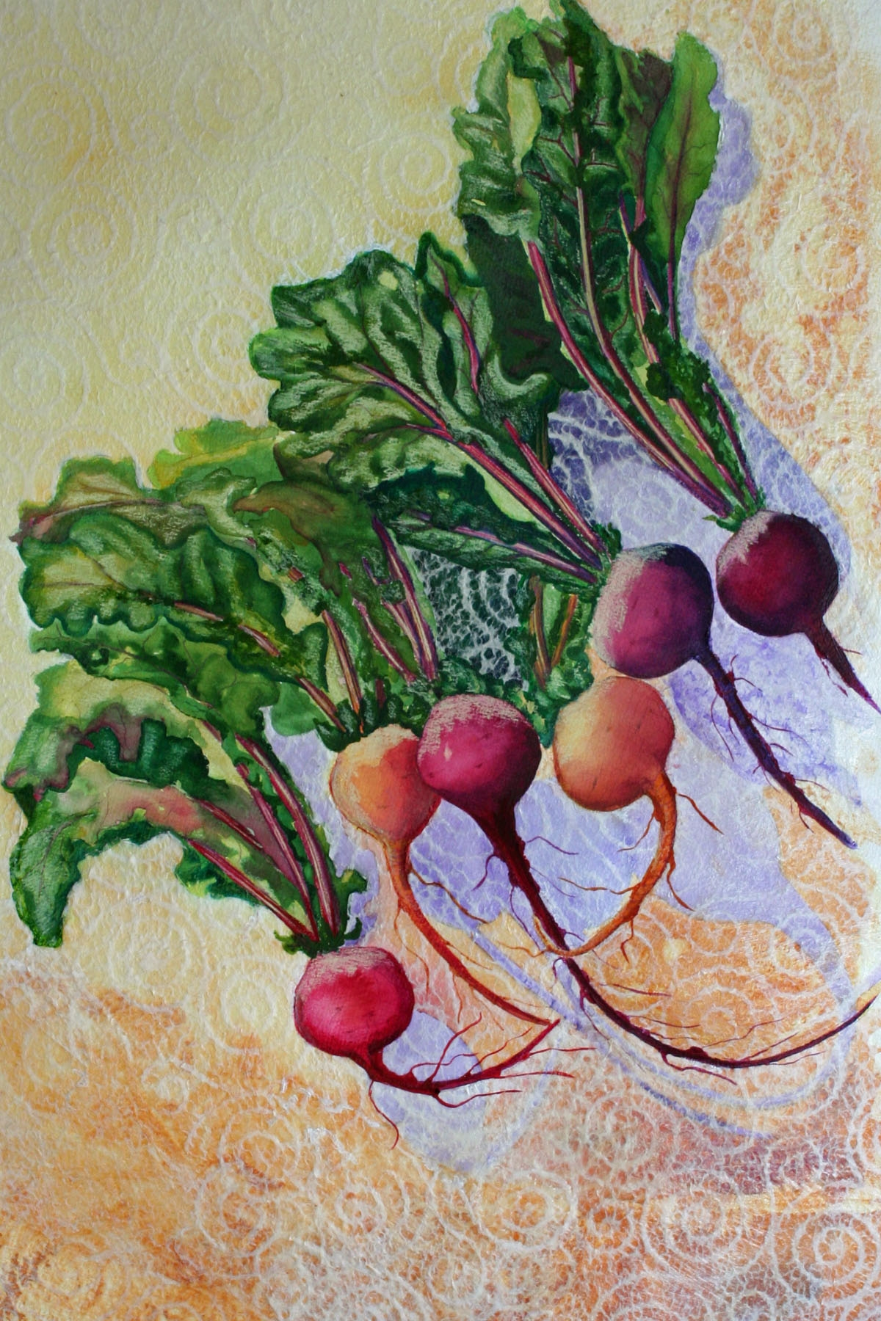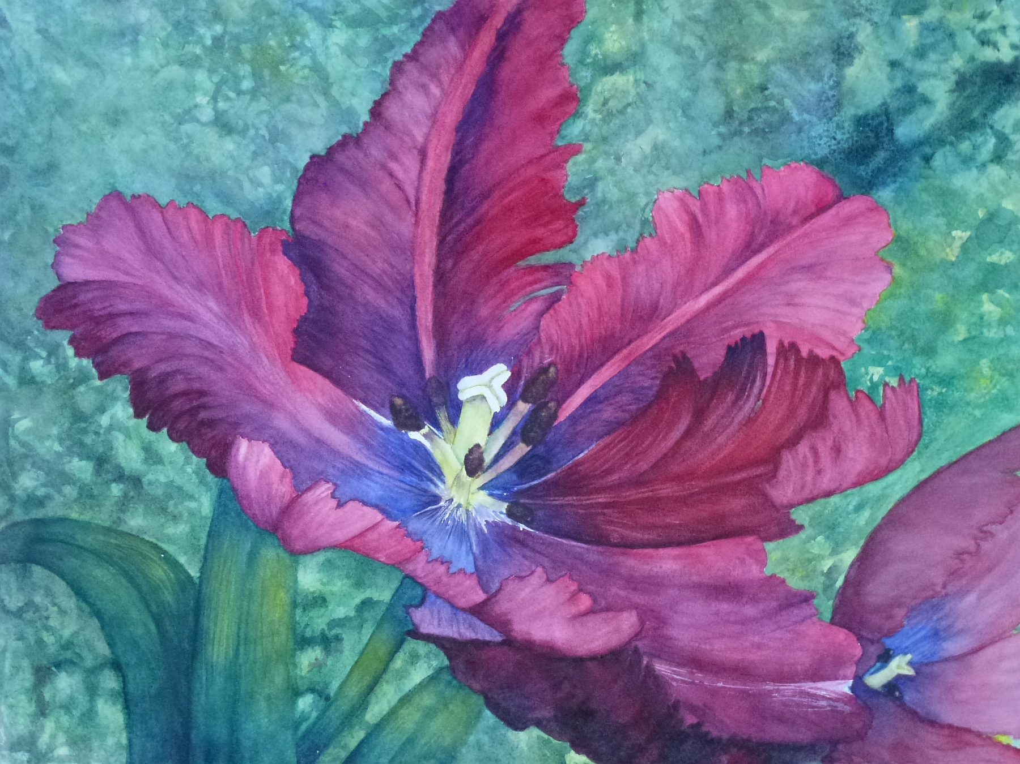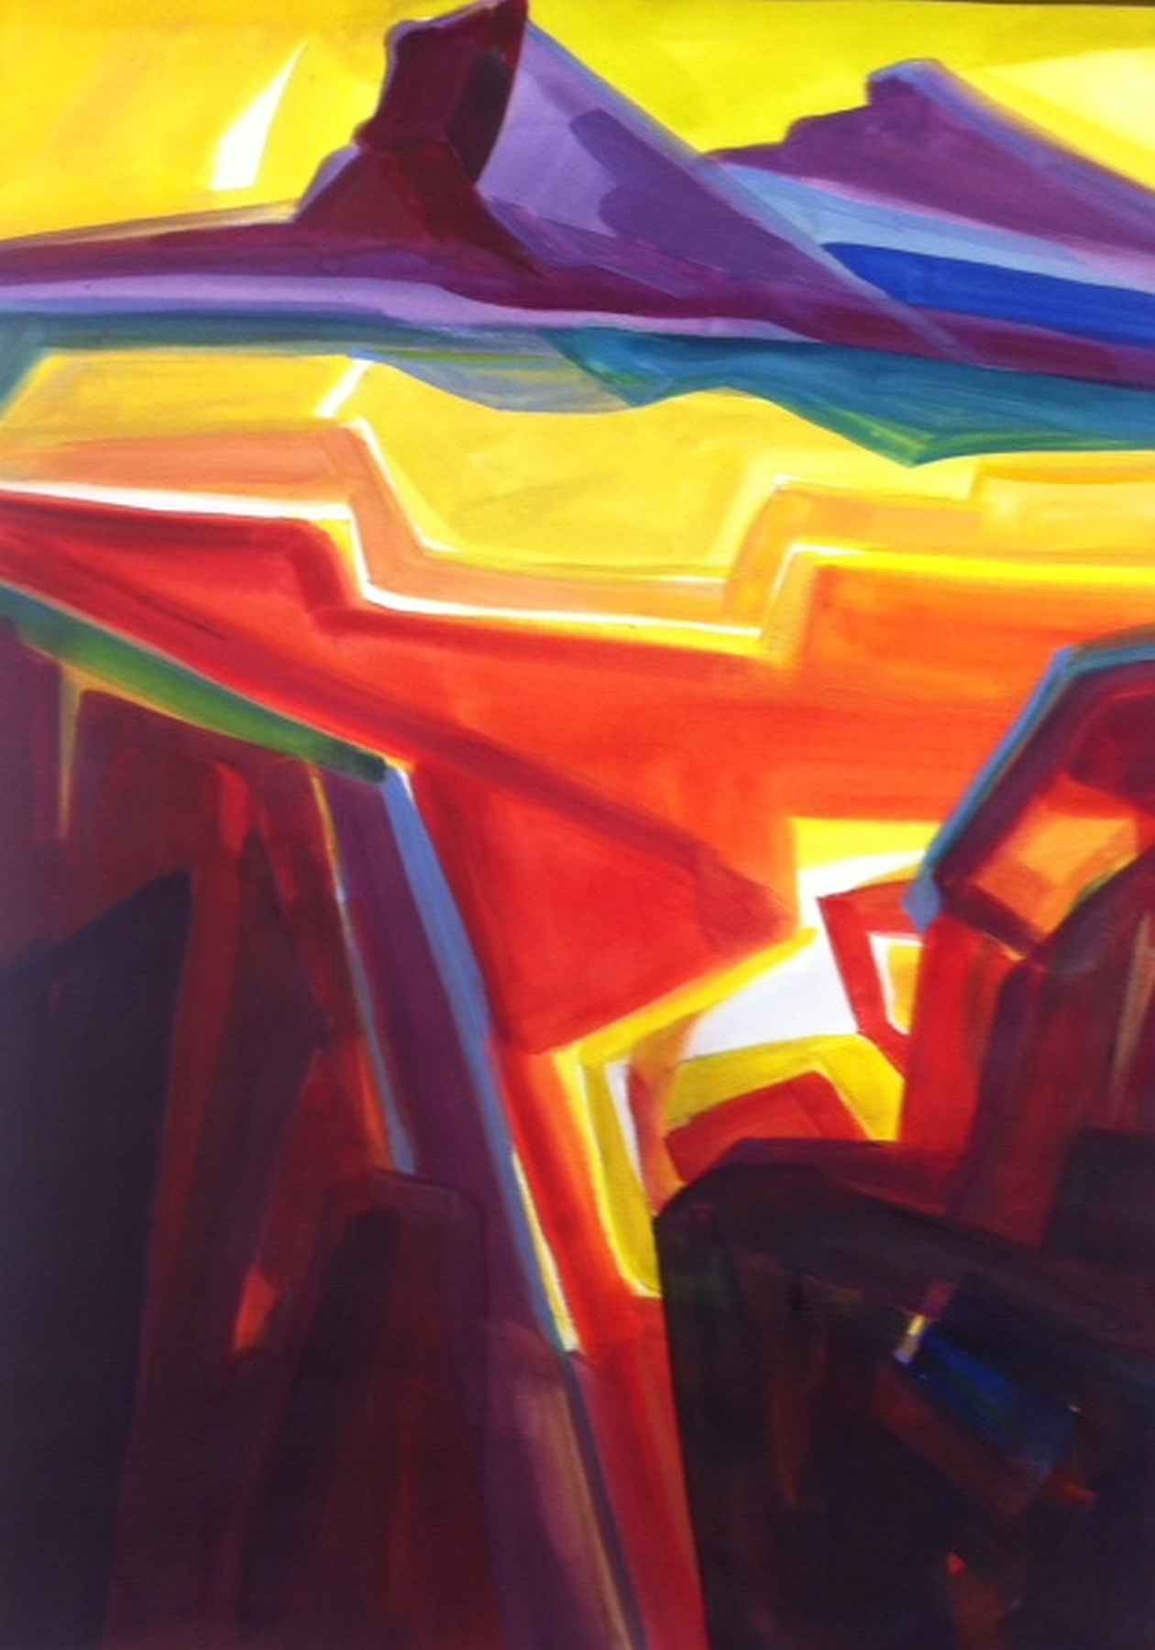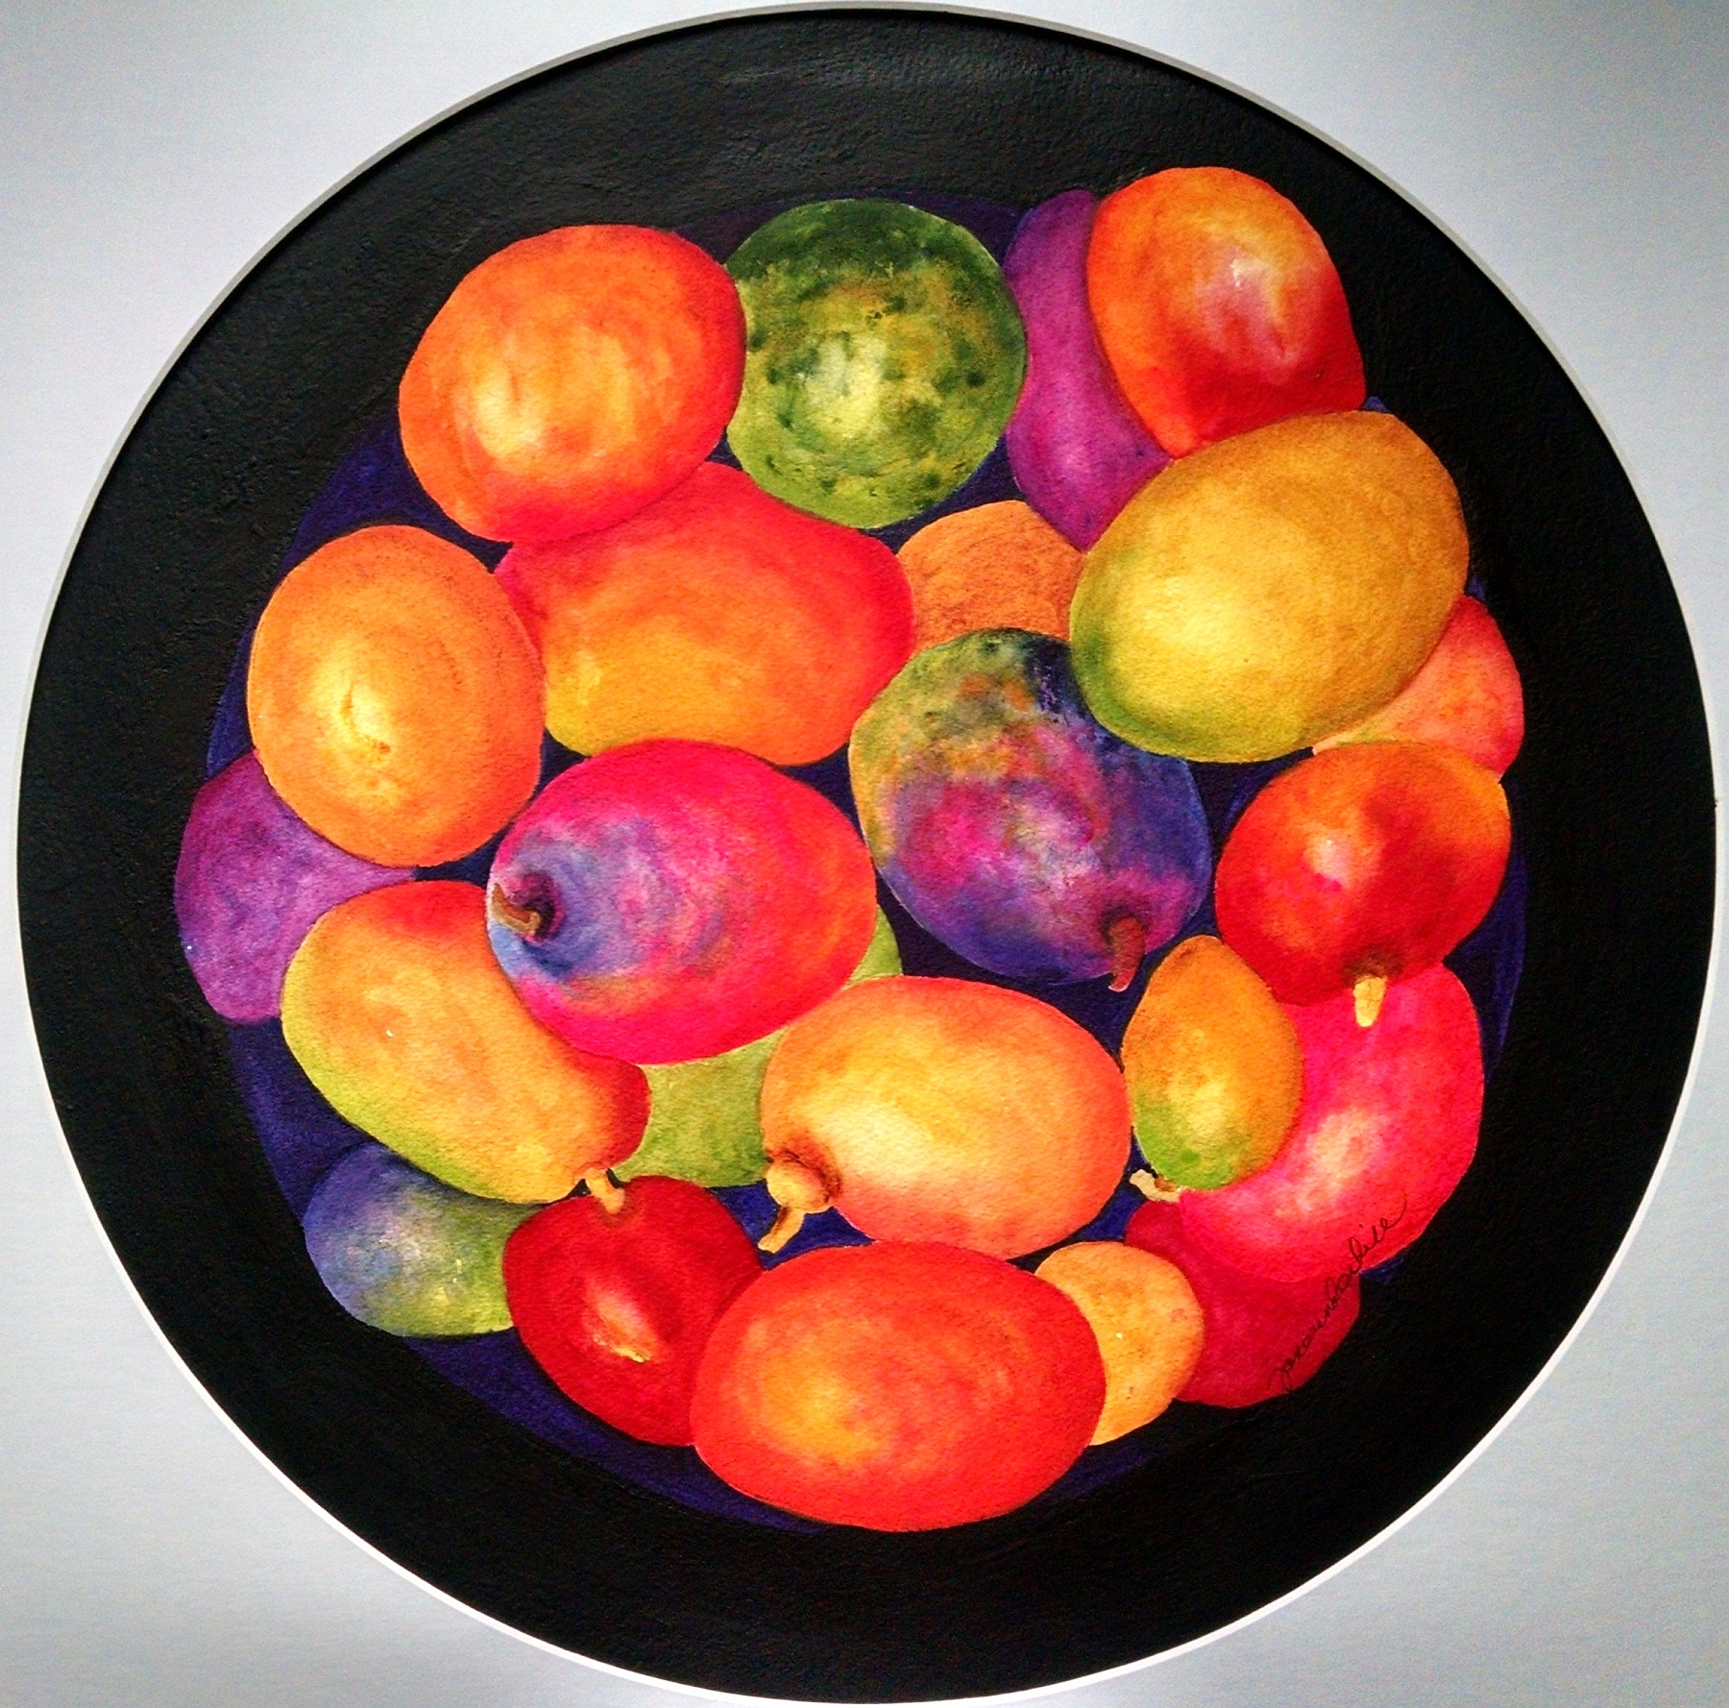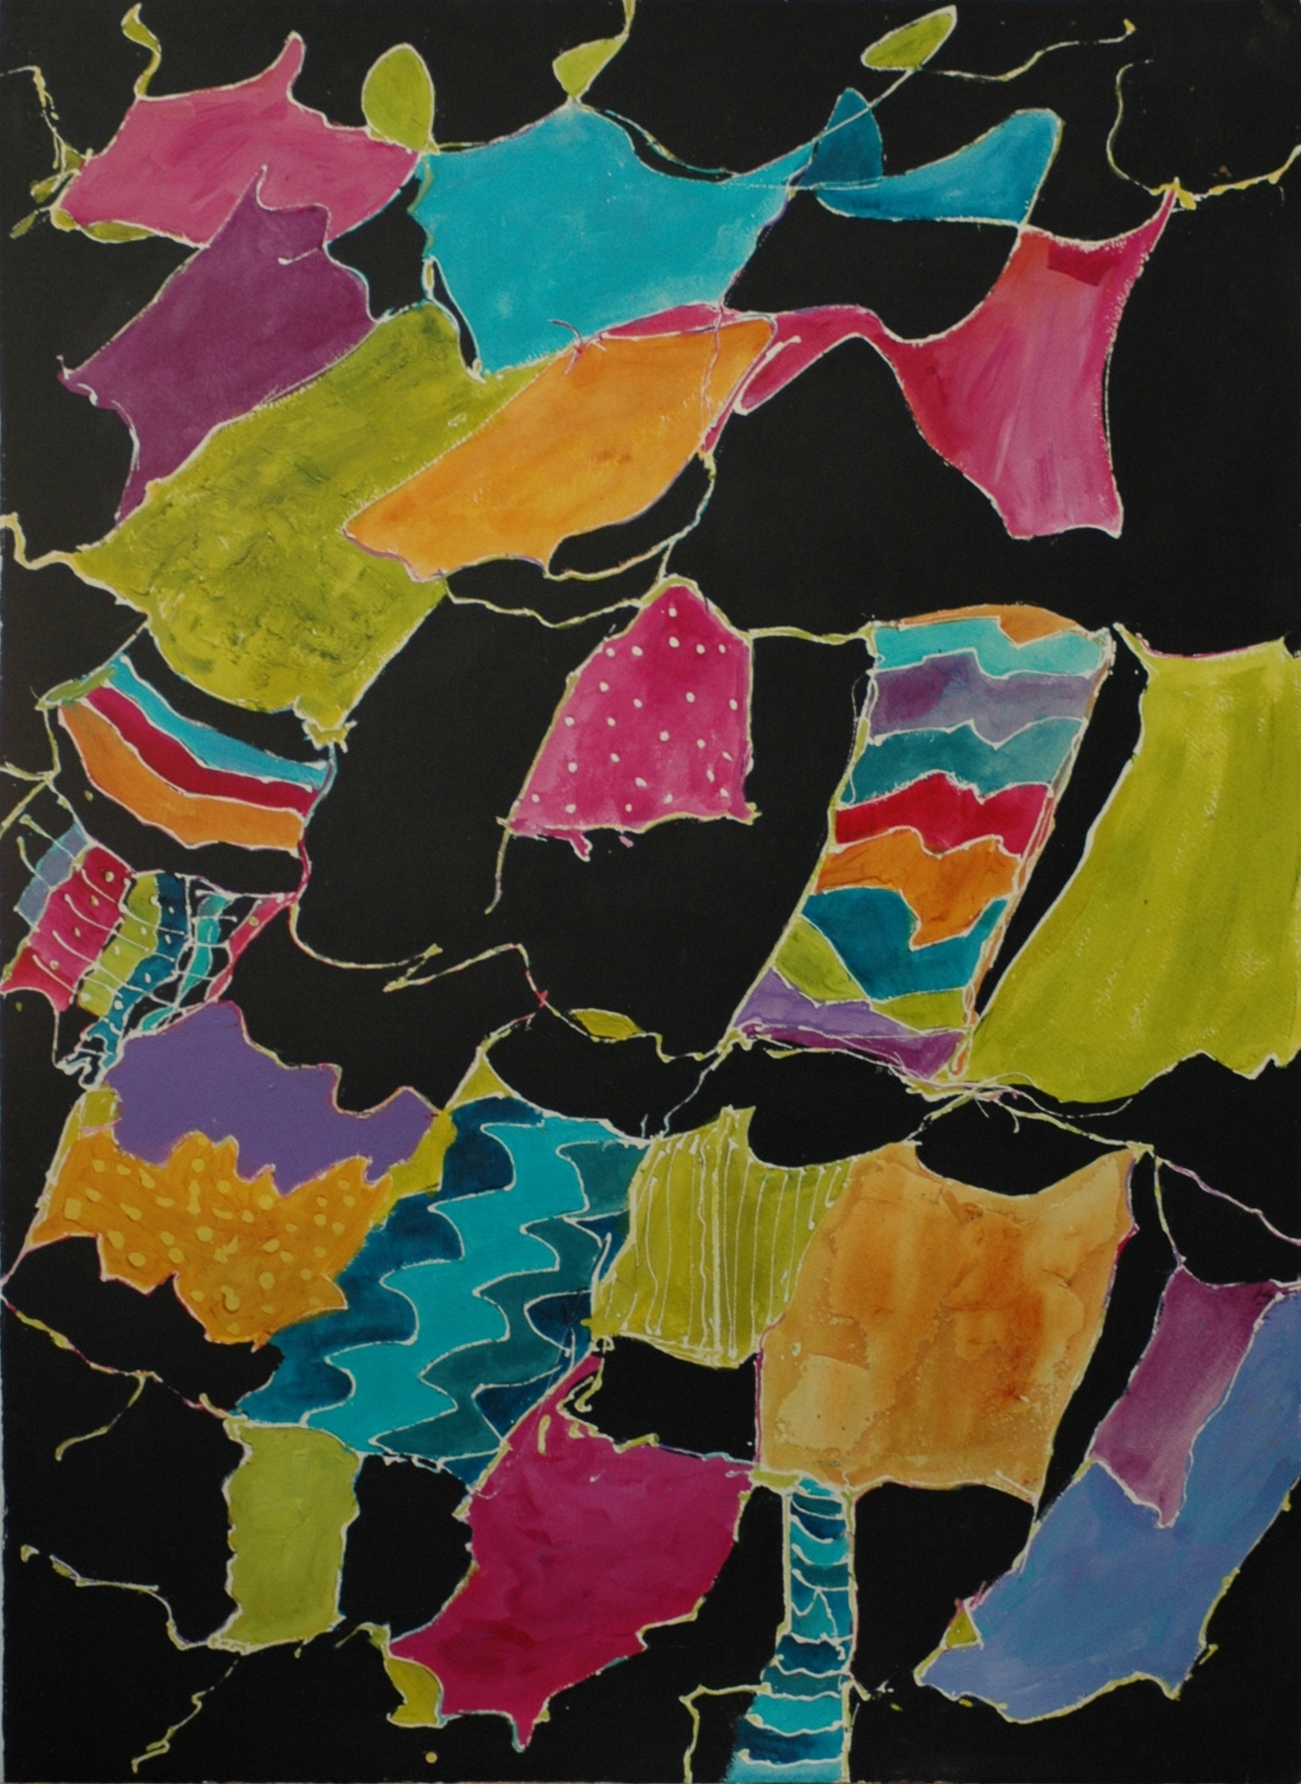

Spring 2016 Show Calendar

February 15: Deadline for Digital Entries
March 16: Artists Notified
April 2: Shipped Paintings are DUE
April 6: (Wednesday) 10 to noon, Hang Show
April 6th at noon: Show Opens
April 13: Juror selects awards
April 14: Juror gives demo at AWA Mtg at AAG Bldg
April 21: Artist Reception & Awards 5:00-7:00
May 7: Pick-up Paintings 10 To Noon.
Awards
Best of Show, Awards of Excellence, Awards of Merit, Juror's Award, Merchant Awards

Juror: Mel Stabin
Mel Stabin, AWS, NWS, TWSA, NEWS, NJWS, GWS is an internationally recognized teacher, author and award-winning watercolorist. A graduate of Pratt Institute, Mel studied under Edgar Whitney and worked over 30 years as art director and creative director for major New York City advertising agencies. In addition to conducting artist workshops in the US and abroad, Mel has written numerous feature articles for American Artist, The Artist’s Magazine, Watercolor Artist, Watercolor Magic and Watercolor and has authored “Watercolor: Simple, Fast and Focused” and “The Figure In Watercolor: Simple, Fast and Focused.”

Eligibility
The Spring 2016 Membership show is open to ALL MEMBERS with current dues paid.
Approximately 64 paintings will be selected.
Materials for this show
AWA is a progressive supporter of water-based arts and invites your suggestions for advancing the art. This is a competition, so emphasis is placed on the work rather than on the framing. Various water-media including transparent watercolor, acrylic and gouache are acceptable on all forms of white and off-white paper, synthetic paper (such as YUPO) or white paper surface on board. Clay surfaces are not acceptable but gesso texture may be applied to the paper prior to painting. Textured boards, such as canvas surfaces, are not acceptable. Collage is acceptable when white paper is used. Minimal image size is 10”x10”, maximum is 22”x30”. Handmade stamps by the artist may be used. Check on azwatercolor.com to see complete updates of the rules.

AZ Watercolor Association
Exhibition Guidelines

Digital Image Entry Information Submittal of a digital image grants AWA permission to use the image for limited publicity related to the show. Entries may be submitted on a CD or by e-mail to: Carol Baker, 18862 N 90th Way, Scottsdale, AZ 85255 or carolbakerart@cox.net.
Submitted images are to be formatted as jpegs at 300 dpi and 1200x1800 pixels with 1800 as the longest side. Crop the image so that only the painting shows. Unless you have special lights, take the picture in natural daylight for accurate colors. A digital camera with megapixels of 8 or higher is best. Some computer e-mail programs, such as MacIntosh, automatically re-size photos to 72 dpi if you attach them to e-mail as a “picture”. This can be avoided by attaching images as “files.” If the image is manipulated to not faithfully show the painting, the painting will be disqualified.

Naming your image(s)
Each image must be named using the first four letters of your last name + first four letters of
your first name, hyphen(-), then the title of the painting. You may abbreviate the title. Example: a painting by Winslow Homer called “Sailboat” would be Homewins-Sailboat.jpg.

Images will be returned if they do not conform to the above format for re-sizing and naming. Please refer to our website for additional instruction information (azwatercolor.com) and/or find a friend who can help you.

Entry Fees
One entry: $30
Two entries: $35 total
Three entries: $40 total
A check made out to AWA, entry form and self- addressed stamped envelope must be mailed to: Jane Underhill, 7907 N 16th Dr, Phoenix, AZ 85021.

Accepted works
Notification will be sent to all entrants on March 16th with additional instructions for accepted work.

Labeling your paintings
The back upper right hand corner of your painting(s) should specify your name, image title, price (or NFS) and phone number.

Sales
AWA will arrange for buyers to contact artists for sales. Submittal for the show indicates permission to exhibit the work on the AWA website. Work is assumed for sale unless labeled “NFS.” In any case, list a value for insurance.

Refer to resizing, matting and framing guidelines online: azwatercolor.com. Contact either Carol Baker (480-998-3166) or Jane Underhill (602-795-3545) with questions and/or for help.

Artist Checklist

__ Photo work with the highest resolution possible.

___ Resize image(s) to 300 dpi and 1800 pixels on longest side.

___ Title images as example (above): Homewins-Sailboat.jpg.

___ Email or mail a CD of digital images to: Carol Baker: carolbakerart@cox.net or 18862 N 90th Way, Scottsdale, AZ 85255.

___ Mail your entry form, fee check and self-addressed stamped envelope before the deadline of February 15th to: Jane Underhill, 7907 N 16th Dr, Phoenix, AZ 85021.

___ Save a copy of the prospectus and your completed entry form to refer to.

___ Label the back of your painting(s) as directed above.

Happy painting and good luck!

Spring 2016 Exhibition Entry Form

Artist: ____________________________________________
Address: __________________________________________
City/State/Zip: _____________________________________
Phone: ( ) _______ - _______________
E-mail address: _____________________________________

Entry 1
Digital file Name:
Title: _____________________________________________
Price (or insurance value if NFS) $______________________
Frame Size: H__________ x W_____________

Entry 2
Digital file Name:
Title: _____________________________________________
Price (or insurance value if NFS) $______________________
Frame Size: H__________ x W_____________

Entry 3
Digital file Name:
Title: _____________________________________________
Price (or insurance value if NFS) $______________________
Frame Size: H__________ x W_____________

Agreement: Submission of digital image(s), if accepted, shall be an agreement on the part of the artist to comply with the following conditions: Entry images of accepted paintings go into the AWA collection. Accepted entries will be featured on the AWA website and, if for sale, prices will be indicated. Artists who renege or withdraw work prior to the close of the show will not be eligible to enter an AWA show for a period of one year. Work not removed at the end of the show will result in a fine of $10 per day unless prior arrangements have been made. AWA will attempt to contact you. After one week, the artist is ineligible to enter the following AWA show. After one month, the artist forfeits the painting to the AWA. I hereby agree to release show personnel and venue staff from all claims or loss of paintings or digital images.

Artist Signature Date

Please include the artist's name, painting title, price and phone number
on the back of each painting.

